Smart Bluetooth Module With Shield—Master

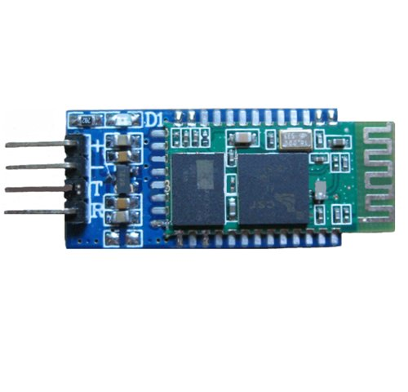
This shield have extract the VCC、GND、TXD、RXD of the bluetooth.（TXD、RXD are both 3.3V）
This shield have LED indication light.
Input Voltage ： 3.3V-6V
Size : 16.3mm*39mm
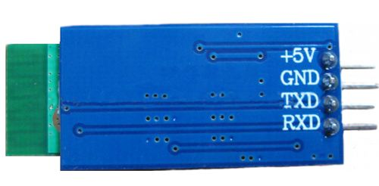
Application :
This item can be used as a normal serial port bluetooth , and can communicate with PC、Mobile Phone etc.
This item can connect with kinds of serial port devices.
This item can be also expanded for second time with kinds of equipments such as GPS etc.
A clearing effective distance is 10 meters
Note :
1、Master modules and slave modules can not switch mode from each other, and only can work as a single work mode
2、 The master modules can only use with this slave modules, and the master modules can not match with other slave modules such as the computer、cell phones and other bluetooth device etc.
3、The slave modules can match with other slave modules such as the computer、cell phones and other bluetooth device etc.
4、 The master modules have the same At command with the slave modules except for "AT+NAME" , which means the slave modules have At command of "AT+NAME" and The master modules don't have.
5、This module is TTL serial port : pin is a TTL level interface, it can works well under the condition of all kinds of baud rate
Connection :

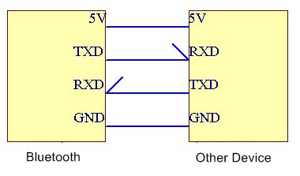
Click to download reference schematic diagram
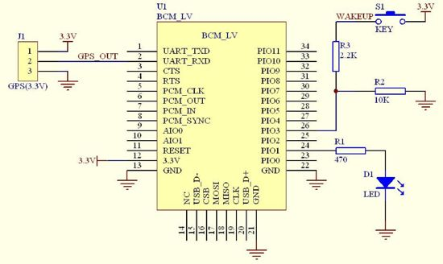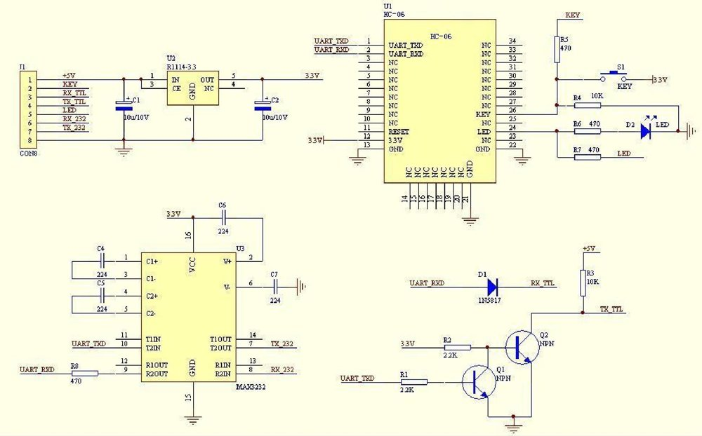

HC-06 Serial Port Bluetooth Module
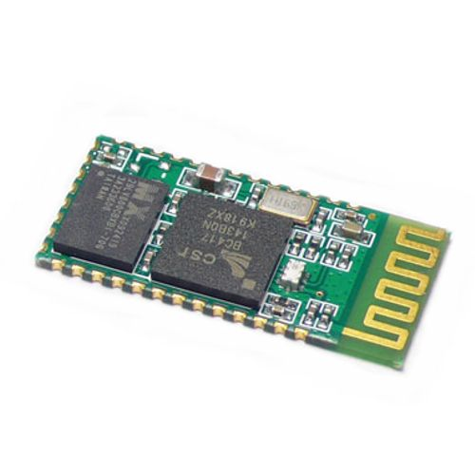
Description :
Serial port bluetooth, Drop-in replacement for wired serial connections, transparent usage. You can use it simply for a serial port replacement to establish connection between MCU and GPS, PC to your embedded project and etc.
And now, we provide HC-05 and HC-06. HC-05 could be setting to Master or Slave by user. HC-06 has be designed Master or Slave when the factory, user couldn't change the role.
Note : HC-06 need you choose Master or Slave(default), HC-05 does not matter.
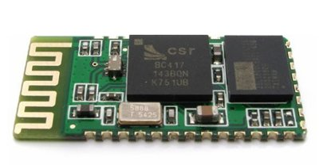
Feature :
1、Bluetooth protocal: Bluetooth Specification v2.0+EDR
2、Frequency: 2.4GHz ISM band
3、Modulation: GFSK(Gaussian Frequency Shift Keying)
4、Emission power: ≤4dBm, Class 2
5、Sensitivity: ≤-84dBm at 0.1% BER
6、Speed: Asynchronous: 2.1Mbps(Max) / 160 kbps, Synchronous: 1Mbps/1Mbps
7、Security: Authentication and encryption
8、Profiles: Bluetooth serial port
9、Power supply: +3.3VDC 50mA
10、Working temperature: -20 ~ +75 Centigrade
11、Dimension: 26.9mm x 13mm x 2.2 mm
Default :
Slave, 9600 baud rate, N, 8, 1. Pincode 1234
AT command :
1. Communications Test :
Sent : AT
receive : OK
2. Change baud rate :
Sent : AT+BAUD1
receive : OK1200
Sent : AT+BAUD2
Receive : OK2400
1---------1200
2---------2400
3---------4800
4---------9600
5---------19200
6---------38400
7---------57600
8---------115200
Baud rate setting can be save even power down.
3. Change Bluetooth device name :
Sent : AT+NAMEdevicename
receive : OKname
(devicename is the name you want the device to be , and it will be searched with this name)
Name setting can be save even power down.
4. Change Pincode :
Sent : AT+PINxxxx
receive : OKsetpin
(xxxx is the pin code you set)
Pin code can be save even power down.
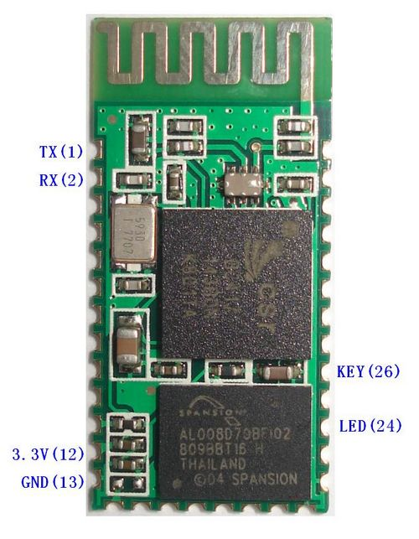
Application :
1、Computer and peripheral devices
2、GPS receiver
3、Industrial control
4、MCU projects
5、Mouse, keyboard, joystick
Documents Download :
Bluetooth HC-06 Datasheet and AT Command
Protel DXP
Eagle

*Review title
Please enter subject.
*Your review

Please enter review.
*Rating
(Click star icon to comment)
Display name


Tell a friend
Your e-mail* | Required
Enter Your Friend's E-mail Address(es)* | Required  Please separate emails by comma. e.g. anne@example.com,sam@example.com
Subject* | Required
Message* | Required
 | 

Related Items
- 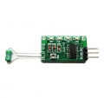

Mini Classical Serial Bluetooth Module
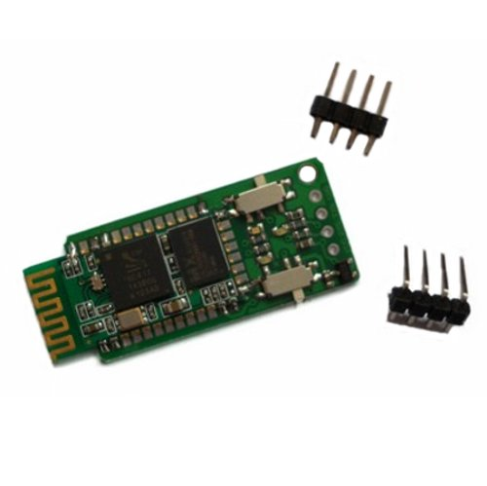
Description：
Mini Classical Serial Bluetooth Module is the most powerful bluetooth module that we have by now. It will be very simple for you to establish a wireless UART/RS232 communication between your devices, even if you don't know the comprehension of how it works.
Mini Classical Serial Bluetooth Module can act as both master mode and slave mode, and you can choose the mode yourselves. For different power supply, this serial bluetooth is compatible with both 3.3V and 5V, and can be also fully compatible with most microcontroller systems.
It supports up to 36 configuring commands (AT commands), which ensures its flexibility in application. It have the function of data encryption, power saving, connection bind, extended I/O interface, RSSI etc.
Characteristic Features :
1、It support both master mode and slave mode ( The working mode is up to you )
2、It is compatible with both 3.3V and 5V ( The working voltage is up to you)
3、It can be fully compatible with most microcontroller systems
4、It supports 36 configuring commands (AT commands)
5、It support UART TTL interface
6、It is very smart but very easy to use
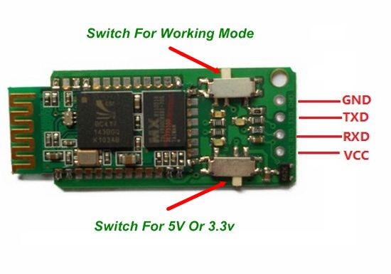
Now just enjoy it :
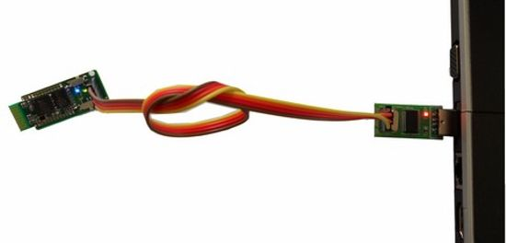
Application :
1、Computer And Some Other Peripheral Devices
2、GPS Receiver
3、Industrial Control
4、MCU Projects
5、Mouse, Keyboard, Joystick
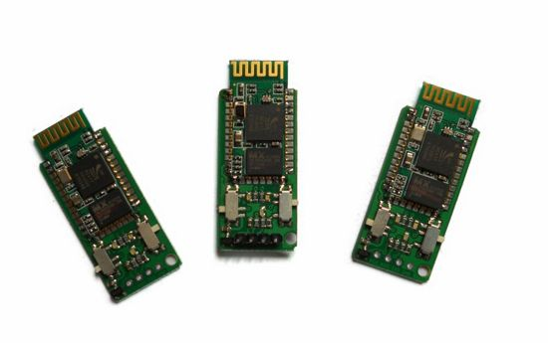

Serial Port Bluetooth With ExpansionBoard（Master）

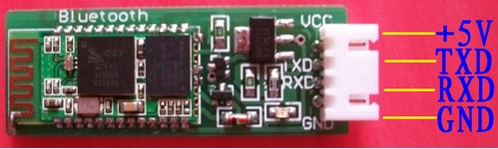

Bluetooth master/slave module has 4 pins :
Pin 1: +5 V power supply
Pin 2: Data sending Pin (which can be connected with the RXD serial terminal of other other chips)
Pin 3: Data receiving Pin (which can be connected with the TXD serial terminal of other other chips)
Pin 4: GND Ground

Here are some usage examples :
Example 1 : PC serial port + RS232-TTL conversion circuit + Bluetooth master module + Bluetooth slave module
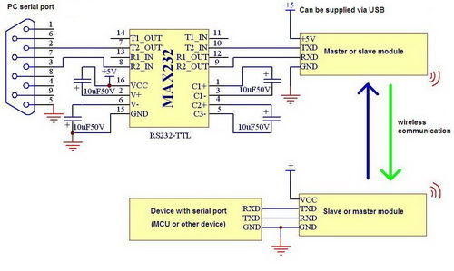
Note : in the example above, master and slave bluetooths can exchange their places, which will not affect data communications. However, on occasions that confidential communications is required, slave bluetooth is connected with PC and master bluetooth is connected equipment terminal, because mobile phones and computers with bluetooth or other Bluetooth devices can not search the master module, but the slave module)
Example 2 : USB-TTL conversion module + master Bluetooth module + slave Bluetooth module
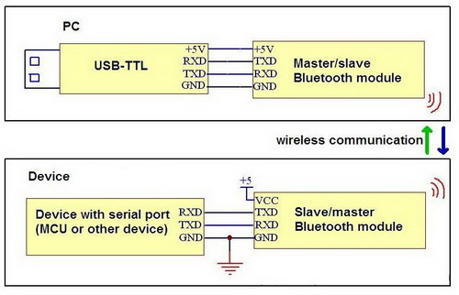
Note : in the example above, master and slave bluetooths can exchange their places.
Example 3 : PC Bluetooth adapter + master Bluetooth module + slave Bluetooth module
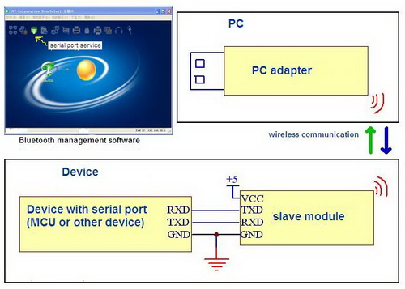
Note : in example 3 PC Bluetooth adapter has to work with slave Bluetooth module because it can not pair with master Bluetooth module. Please install IVT Corporation BlueSoleil before using PC Bluetooth adapter. Bluetooth mobile phones and Bluetooth devices can also pair with slave Bluetooth module. Data communication can happen between each other. But Bluetooth management software is needed on Bluetooth mobile phone.
Example 4 : equipments with serial port + master Bluetooth module+ slave Bluetooth module
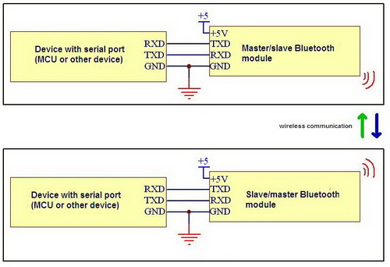
Note : in example 4, the two equipments can send or receive data wirelessly. they were connected with master Bluetooth module and slave Bluetooth module. When Bluetooth modules are powered on, they will pair with each other automatically, without manually entering the password.
Usage :
1. If you use master Bluetooth mudule and slave Bluetooth mudule to communicate, the two modules will pair with each other automatically.
2. If you use Bluetooth adapter and slave Bluetooth mudule, please install BlueSoleil. Search for devices using BlueSoleil, and the slave Bluetooth mudule will be found. Then select "match" option, enter the password 1234, then OK. Then you can use the serial service.

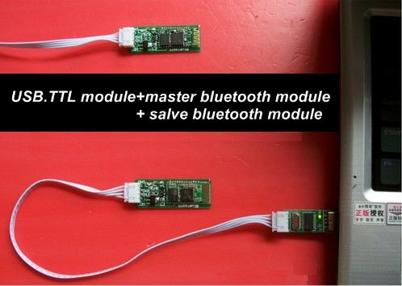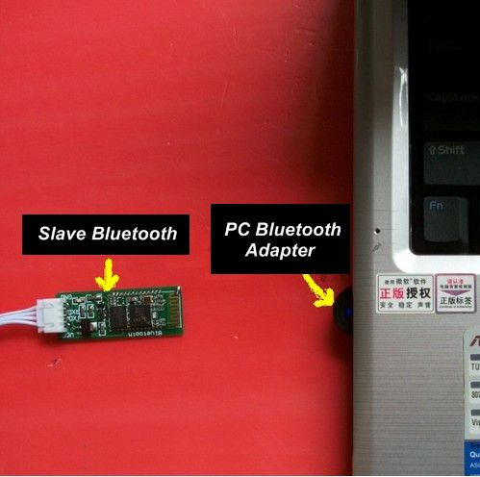
Baud rate : 1200,2400,4800,9600,19200,38400,57600,115200,230400,460800,921600,1382400. Users are free to change or set it. The default baud rate is 9600.
Frequency: 2.4GHZ-2.48GHZ.ISM Band
Bluetooth protocol: BlueTooth V2.0 standard
Receiving sensitivity: -85dBm
Operating Voltage: 5V
Operating temperature: -40 centigrade to +105 centigrade
Power rating: Class2 (+6 dBm)
Reference Power consumption: 35mA(searching), 8mA(paired)
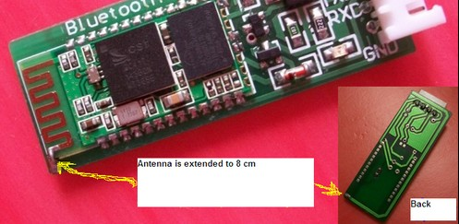
How to change the setting? (we do not recommend to modify the default settings which can satisfy most needs)
Step 1 : modify the COM settings :
COM:(according to the PC)
Baud rate: 9600
Test bits: N
Data bits: 8
Stop bit: 1
Step 2 : Before the module is paired(when LED lights is flashing), sends the following commands to modify Bluetooth parameters :
1. modify the baud rate
Send: AT + BAUD1 ("1" is a serial number, please refer to the following to find the baud rate you want)
Return: OK1200
Baud rate of the serial number as follows :
* 1 --------- 1200
* 2 --------- 2400
* 3 --------- 4800
* 4 --------- 9600
* 5 --------- 19200
* 6 --------- 38400
* 7 --------- 57600
* 8 --------- 115200
* 9 --------- 230400
* A --------- 460800
* B --------- 921600
* C --------- 1382400
Baud rate above 115200 is not recommend, because the signal interference will make the system unstable. While baud rate is above 115200, the baud rate can not be changed by PC. You have to use MCU to send commands to modify it.
2. modify the Bluetooth name
Send AT + NAMEname ("name" is the name you want, within 20 characters)
Return: OKname
3. modify pairing code
Send AT + PINxxxx ("xxxx" is the password you want)
Return: OKsetpin
4. In order to test the communication between Bluetooth module and PC, send the following command test
Send: AT (if return "OK", communication is successful.)
Return: OK
Product list:
1. Slave Bluetooth Module
2. Connection wire
Size : 5.2cm*1.8cm
Clear the memory
This module has been set with a default address in the memory. If you want it to pair with other bluetooth, you may need to delete the memory. It is very easy. As the picture shows below, find the two points in the red circles and short them for a quick period. Repeat them for several times to make sure it works.
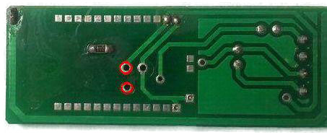
Please Note : Do be careful while you connect Power to bluetooth module. Please make sure they are correctly connectly. Otherwise the module will be easily burned.
Click to see more detail inforamtion about Serial Port Bluetooth

Serial Port Bluetooth With ExpansionBoard（Slave）

Bluetooth master/slave module has 4 pins :
Pin 1: +5 V power supply
Pin 2: Data sending Pin (which can be connected with the RXD serial terminal of other other chips)
Pin 3: Data receiving Pin (which can be connected with the TXD serial terminal of other other chips)
Pin 4: GND Ground

Here are some usage examples :
Example 1 : PC serial port + RS232-TTL conversion circuit + Bluetooth master module + Bluetooth slave module
Note : in the example above, master and slave bluetooths can exchange their places, which will not affect data communications. However, on occasions that confidential communications is required, slave bluetooth is connected with PC and master bluetooth is connected equipment terminal, because mobile phones and computers with bluetooth or other Bluetooth devices can not search the master module, but the slave module)
Example 2 : USB-TTL conversion module + master Bluetooth module + slave Bluetooth module
Note : in the example above, master and slave bluetooths can exchange their places.
Example 3 : PC Bluetooth adapter + master Bluetooth module + slave Bluetooth module
Note : in example 3 PC Bluetooth adapter has to work with slave Bluetooth module because it can not pair with master Bluetooth module. Please install IVT Corporation BlueSoleil before using PC Bluetooth adapter. Bluetooth mobile phones and Bluetooth devices can also pair with slave Bluetooth module. Data communication can happen between each other. But Bluetooth management software is needed on Bluetooth mobile phone.
Example 4 : equipments with serial port + master Bluetooth module+ slave Bluetooth module
Note : in example 4, the two equipments can send or receive data wirelessly. they were connected with master Bluetooth module and slave Bluetooth module. When Bluetooth modules are powered on, they will pair with each other automatically, without manually entering the password.
Usage :
1. If you use master Bluetooth mudule and slave Bluetooth mudule to communicate, the two modules will pair with each other automatically.
2. If you use Bluetooth adapter and slave Bluetooth mudule, please install BlueSoleil. Search for devices using BlueSoleil, and the slave Bluetooth mudule will be found. Then select "match" option, enter the password 1234, then OK. Then you can use the serial service.

Baud rate : 1200,2400,4800,9600,19200,38400,57600,115200,230400,460800,921600,1382400. Users are free to change or set it. The default baud rate is 9600.
Frequency: 2.4GHZ-2.48GHZ.ISM Band
Bluetooth protocol: BlueTooth V2.0 standard
Receiving sensitivity: -85dBm
Operating Voltage: 5V
Operating temperature: -40 centigrade to +105 centigrade
Power rating: Class2 (+6 dBm)
Reference Power consumption: 35mA(searching), 8mA(paired)
How to change the setting? (we do not recommend to modify the default settings which can satisfy most needs)
Step 1 : modify the COM settings :
COM:(according to the PC)
Baud rate: 9600
Test bits: N
Data bits: 8
Stop bit: 1
Step 2 : Before the module is paired(when LED lights is flashing), sends the following commands to modify Bluetooth parameters :
1. modify the baud rate
Send: AT + BAUD1 ("1" is a serial number, please refer to the following to find the baud rate you want)
Return: OK1200
Baud rate of the serial number as follows :
* 1 --------- 1200
* 2 --------- 2400
* 3 --------- 4800
* 4 --------- 9600
* 5 --------- 19200
* 6 --------- 38400
* 7 --------- 57600
* 8 --------- 115200
* 9 --------- 230400
* A --------- 460800
* B --------- 921600
* C --------- 1382400
Baud rate above 115200 is not recommend, because the signal interference will make the system unstable. While baud rate is above 115200, the baud rate can not be changed by PC. You have to use MCU to send commands to modify it.
2. modify the Bluetooth name
Send AT + NAMEname ("name" is the name you want, within 20 characters)
Return: OKname
3. modify pairing code
Send AT + PINxxxx ("xxxx" is the password you want)
Return: OKsetpin
4. In order to test the communication between Bluetooth module and PC, send the following command test
Send: AT (if return "OK", communication is successful.)
Return: OK
Product list:
1. Slave Bluetooth Module
2. Connection wire
Size : 5.2cm*1.8cm
Clear the memory
This module has been set with a default address in the memory. If you want it to pair with other bluetooth, you may need to delete the memory. It is very easy. As the picture shows below, find the two points in the red circles and short them for a quick period. Repeat them for several times to make sure it works.
Please Note : Do be careful while you connect Power to bluetooth module. Please make sure they are correctly connectly. Otherwise the module will be easily burned.
Serial Port Bluetooth Module (Slave)
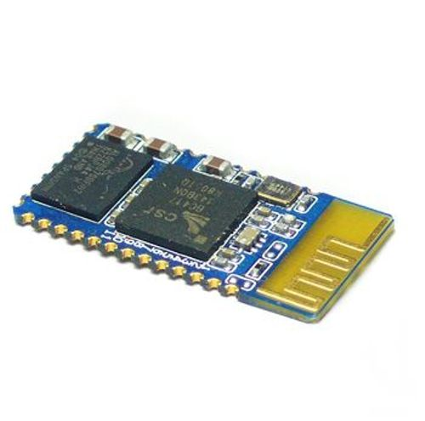
Industrial serial port bluetooth, Drop-in replacement for wired serial connections, transparent usage. You can use it simply for a serial port replacement to establish connection between MCU and GPS, PC to your embedded project and etc.
Default serail port setting : 115200(optional 4800,9600,19200), N, 8, 1
Pairing code : 1234
Running in slave role: Pair with BT dongle and master module.
Specification :
Bluetooth protocal : Bluetooth Specification v2.0+EDR
Frequency : 2.4GHz ISM band
Modulation : GFSK(Gaussian Frequency Shift Keying)
Emission power : ≤4dBm, Class 2
Sensitivity : ≤-84dBm at 0.1% BER
Speed : Asynchronous: 2.1Mbps(Max) / 160 kbps ; Synchronous: 1Mbps/1Mbps
Security : Authentication and encryption
Profiles : Bluetooth serial port(master & slave)
CSR chip : Bluetooth v2.0
Wave band : 2.4GHz—2.8GHz, ISM Band
Protocol : Bluetooth V2.0
Power Class : (+6dbm)
Reception sensitivity: -85dBm
Voltage : +3.3V 50mA (2.7V—4.2V)
Current : Paring - 35mA, Connected - 8mA
Temperature : -20℃~ +55℃
User defined Baud rate :
200, 4800, 9600, 19200, 38400, 57600, 115200, 230400, 460800, 921600, 1382400
Dimension : 26.9mm*13mm*2.2mm
Coupled Mode: Two modules will establish communication automatically when powered.
PC hosted mode: Pair the module with bluetooth dongle directly as virtual serial.
Pin Definition :
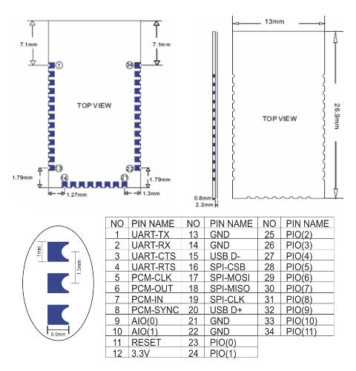

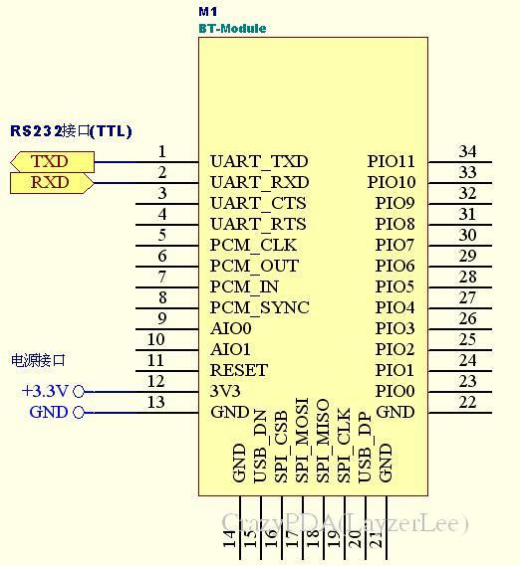

Common Pin Explanation :
1、PIO8 connects with LED cathodea with 470ohm series resistor in between. LED NEGATIVE connects to ground. It is used to indicate the module state. After powered on, flashing intervals differ in different states.
2、PIO9 is used to control LED indicating paring. It will be steady on when paring is successful.
3、PIO11, module state switching pin. HIGH -> response to AT command; LOW or floating -> regular work status.
4、With build-in reset circuit, reset is completed automatically after powered on.
Steps to set as master mode :
1、Set PIO11 HIGH with a 10K resistor in between.
2、Power on, module comes into AT Command Response Status
3、Open HyperTerminal or other serial tool, set the baud rate 38400, 8 data bits, 1 stop bit, no parity bit, no Flow Control
4、Via serial port, send characters "AT + ROLE = 1 r n",if successful, return "OK r n", where r n is carriage return.
10、Set PIO11 LOW, re-power, then in Master state, automatically search for slave module and connect.
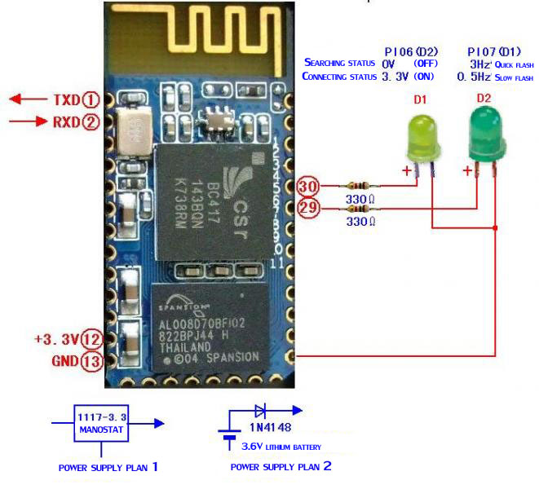
Application :
Computer and peripheral devices
GPS receiver
Industrial control
MCU projects
Document Download Area :
Click to Download the datasheet
Click to Download the manual
Click to Download the AT Command

Serial Port Bluetooth Module With Baseboard (Slave)
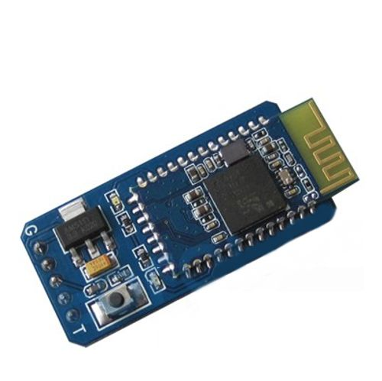
Industrial serial port bluetooth, Drop-in replacement for wired serial connections, transparent usage. You can use it simply for a serial port replacement to establish connection between MCU and GPS, PC to your embedded project and etc.
The default serial port is set to [9600, N, 8,1]
Matching password: 0000
Support the AT commands to modify baud rate, device name, matching password
Support modifying baud rate device name and matching password via AT commands
Support baud: 9600~1382400.
From picture below, it has DIP pins, which is the difference made by baseboard.
Bluetooth Specification :

Bluetooth protocal : Bluetooth Specification v2.0+EDR
Frequency : 2.4GHz ISM band
Modulation : GFSK(Gaussian Frequency Shift Keying)
Emission power : ≤4dBm, Class 2
Sensitivity : ≤-84dBm at 0.1% BER
Speed : Asynchronous: 2.1Mbps(Max) / 160 kbps ; Synchronous: 1Mbps/1Mbps
Security : Authentication and encryption
Profiles : Bluetooth serial port(master & slave)
CSR chip : Bluetooth v2.0
Wave band : 2.4GHz—2.8GHz, ISM Band
Protocol : Bluetooth V2.0
Power Class : (+6dbm)
Reception sensitivity: -85dBm
Voltage : +3.3V 50mA (2.7V—4.2V)
Current : Paring - 35mA, Connected - 8mA
Temperature : -20℃~ +55℃
User defined Baud rate :
200, 4800, 9600, 19200, 38400, 57600, 115200, 230400, 460800, 921600, 1382400
Dimension : 26.9mm*13mm*2.2mm
Board effective antenna
Coupled Mode: Two modules will establish communication automatically when powered.
PC hosted mode: Pair the module with bluetooth dongle directly as virtual serial.
More information for this bluetooth module
This module have one baseboard and Board effective antenna .
Supply voltage for this module : ≥4.8V and ≤12V .
The master mode module can only be used with the slave mode module .
The slave mode module can be used with a variety of Bluetooth adapter、mobile phone etc .
Master module has auto searching function and slave module don't has auto searching function .
Application :
1、Computer and peripheral devices
2、GPS receiver
3、Industrial control
4、MCU projects
5、Mouse, keyboard, joystick
As the picture below, Four DIP pins represent TXD, RXD, NC, VCC and GND, which make usage of this board very easy .
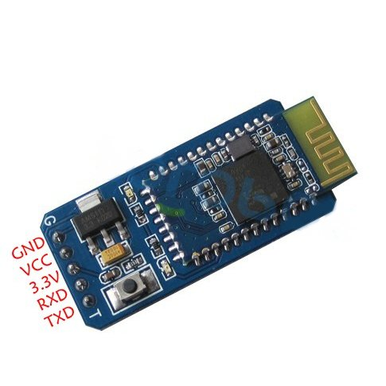
Click to see more detail inforamtion about Slave Mode Serial Port Bluetooth

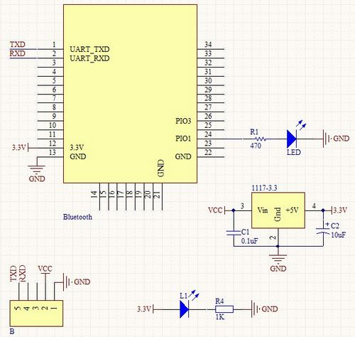

Download the datasheet
Download the manual

下载pdf文档资料.pdf
Serial Port Bluetooth Module (Slave)
Industrial serial port bluetooth, Drop-in replacement for wired serial connections, transparent usage. You can use it simply for a serial port replacement to establish connection between MCU and GPS, PC to your embedded project and etc.
Default serail port setting : 115200(optional 4800,9600,19200), N, 8, 1
Pairing code : 1234
Running in slave role: Pair with BT dongle and master module.
Specification :
Bluetooth protocal : Bluetooth Specification v2.0+EDR
Frequency : 2.4GHz ISM band
Modulation : GFSK(Gaussian Frequency Shift Keying)
Emission power : ≤4dBm, Class 2
Sensitivity : ≤-84dBm at 0.1% BER
Speed : Asynchronous: 2.1Mbps(Max) / 160 kbps ; Synchronous: 1Mbps/1Mbps
Security : Authentication and encryption
Profiles : Bluetooth serial port(master & slave)
CSR chip : Bluetooth v2.0
Wave band : 2.4GHz—2.8GHz, ISM Band
Protocol : Bluetooth V2.0
Power Class : (+6dbm)
Reception sensitivity: -85dBm
Voltage : +3.3V 50mA (2.7V—4.2V)
Current : Paring - 35mA, Connected - 8mA
Temperature : -20℃~ +55℃
User defined Baud rate :
200, 4800, 9600, 19200, 38400, 57600, 115200, 230400, 460800, 921600, 1382400
Dimension : 26.9mm*13mm*2.2mm
Coupled Mode: Two modules will establish communication automatically when powered.
PC hosted mode: Pair the module with bluetooth dongle directly as virtual serial.
Pin Definition :

Common Pin Explanation :
1、PIO8 connects with LED cathodea with 470ohm series resistor in between. LED NEGATIVE connects to ground. It is used to indicate the module state. After powered on, flashing intervals differ in different states.
2、PIO9 is used to control LED indicating paring. It will be steady on when paring is successful.
3、PIO11, module state switching pin. HIGH -> response to AT command; LOW or floating -> regular work status.
4、With build-in reset circuit, reset is completed automatically after powered on.
Steps to set as master mode :
1、Set PIO11 HIGH with a 10K resistor in between.
2、Power on, module comes into AT Command Response Status
3、Open HyperTerminal or other serial tool, set the baud rate 38400, 8 data bits, 1 stop bit, no parity bit, no Flow Control
4、Via serial port, send characters "AT + ROLE = 1 r n",if successful, return "OK r n", where r n is carriage return.
10、Set PIO11 LOW, re-power, then in Master state, automatically search for slave module and connect.
Application :
Computer and peripheral devices
GPS receiver
Industrial control
MCU projects
Document Download Area :
Click to Download the datasheet
Click to Download the manual
Click to Download the AT Command

下载pdf文档资料.pdf

*Review title
Please enter subject.
*Your review

Please enter review.
*Rating
(Click star icon to comment)
Display name

Tell a friend
Your e-mail* | Required
Enter Your Friend's E-mail Address(es)* | Required  Please separate emails by comma. e.g. anne@example.com,sam@example.com
Subject* | Required
Message* | Required

Related Items
- 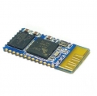
US$16.50
Serial Port Bluetooth Module（Master）



- 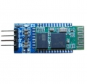
US$16.98
Smart Bluetooth Module With Shield—Slave

US$16.98
Smart Bluetooth Module With Shield—Master

- 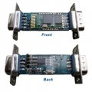
US$19.98
Smart RS232 Bluetooth Module With DB9 Interface

- 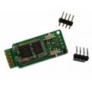
US$17.98
Mini Classical Serial Bluetooth Module

- 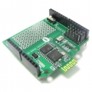
US$28.98
Stackable Bluetooth Shield V2.2

- 